SAGNIK BASU 113EC0199

Simulate a 2input XOR gate using MLP with back-propagation algorithm. Use a MLP with 2 neural layers. The second layer should have only one neuron. Tune the number of neurons in the first layer starting with 2neurons to achieve the result. Repeat the experiment for 3input XOR gate also.

MATLAB CODE :

1) For two input xor gate

% multi layer perceptron

% XOR input for x1 and x2
input = [0 0 ; 0 1 ; 1 0 ; 1 1 ];
% Desired output of XOR
output = [0;1;1;0];
% Initialize the bias
bias = [-1 -1 -1];
% Learning coefficient
coeff = 0.7;
% Number of learning iterations
iterations = 1000;
% Calculate weights randomly using seed.
%rand('state',sum(100*clock));

weights = 5 +2.*rand(3,3);

for i = 1:iterations
out = zeros(4,1);
numIn = length (input(:,1));
for j = 1:numIn
% Hidden layer
H1 = bias(1,1)*weights(1,1)+input(j,1)*weights(1,2)+ input(j,2)*weights(1,3);

% Send data through sigmoid function 1/1+e^-x
% Note that sigma is a different m file
% that I created to run this operation
x2(1) = sigma(H1);
H2 = bias(1,2)*weights(2,1) + input(j,1)*weights(2,2) + input(j,2)*weights(2,3);
x2(2) = sigma(H2);

% Output layer
x3_1 = bias(1,3)*weights(3,1)+ x2(1)*weights(3,2)+x2(2)*weights(3,3);
out(j) = sigma(x3_1);
error_out=0;
mse_iter=50;
for l=1:mse_iter
error_in=0;
for j2=1:numIn
out_mse=sigma(bias(1,1)*weights(1,1)+input(j2,1)*weights(1,2)+ input(j2,2)*weights(1,3));
error_in=error_in+output(j2)-out_mse;
end
error_out=error_out+error_in*error_in;
end
mseo(i)=error_out/mse_iter;

% Adjust delta values of weights
% For output layer:
% delta(wi) = xi*delta,
% delta = (1-actual output)*(desired output - actual output)
delta3_1 = out(j)*(1-out(j))*(output(j)-out(j));

% Propagate the delta backwards into hidden layers
delta2_1 = x2(1)*(1-x2(1))*weights(3,2)*delta3_1;
delta2_2 = x2(2)*(1-x2(2))*weights(3,3)*delta3_1;

% Add weight changes to original weights
% And use the new weights to repeat process.
% delta weight = coeff*x*delta
for k = 1:3
if k == 1 % Bias cases
weights(1,k) = weights(1,k) + coeff*bias(1,1)*delta2_1;
weights(2,k) = weights(2,k) + coeff*bias(1,2)*delta2_2;
weights(3,k) = weights(3,k) + coeff*bias(1,3)*delta3_1;
else % When k=2 or 3 input cases to neurons
weights(1,k) = weights(1,k) + coeff*input(j,1)*delta2_1;
weights(2,k) = weights(2,k) + coeff*input(j,2)*delta2_2;
weights(3,k) = weights(3,k) + coeff*x2(k-1)*delta3_1;
end
end
end
end

%% Plotting in matlab

p = [0 0 1 1; 0 1 0 1];
t = [0 1 1 0];
%plotpv(p,t);
%plotpc(weights,bias)

2) Three input xor gate

% multi layer perceptron

% XOR input for x1 and x2
input = [0 0 0; 0 1 0; 1 0 0; 1 1 0;1 0 1;1 1 1;0 1 1;0 0 1];
% Desired output of XOR
output = [0;1;1;0;0;1;0;1];
% Initialize the bias
bias = [-1 -1 -1 -1];
% Learning coefficient
coeff = 0.7;
% Number of learning iterations
iterations = 2000;
% Calculate weights randomly using seed.
%rand('state',sum(100*clock));

weightsb = -1 +2.*rand(1,4);
weights11= -1 +2.*rand(1,4);
weights12= -1 +2.*rand(1,4);
weights13= -1 +2.*rand(1,4);
weights21= -1 +2.*rand(1,1);
weights22= -1 +2.*rand(1,1);
weights23= -1 +2.*rand(1,1);

for i = 1:iterations
out = zeros(4,1);
numIn = length (input(:,1));
for j = 1:numIn
% Hidden layer
H1 = bias(1,1)*weightsb(1,1)+input(j,1)*weights11(1,1)+ input(j,2)*weights11(1,2)+input(j,3)*weights11(1,3);

% Send data through sigmoid function 1/1+e^-x
% Note that sigma is a different m file
% that I created to run this operation
x2(1) = sigma(H1);
H2 = bias(1,2)*weightsb(1,2) + input(j,1)*weights12(1,1) + input(j,2)*weights12(1,2)+input(j,3)*weights12(1,3);
x2(2) = sigma(H2);

H3 = bias(1,3)*weightsb(1,3) + input(j,1)*weights13(1,1) + input(j,2)*weights13(1,2)+input(j,3)*weights13(1,3);
x2(3) = sigma(H3);

% Output layer
x3_1 = bias(1,4)*weightsb(1,4)+ x2(1)*weights21+x2(2)*weights22+x2(3)*weights23;
out(j) = sigma(x3_1);
error_out=0;
mse_iter=50;
%for l=1:mse_iter
test=xor_test(50);
for l=1:50
error_in=0;

out_mse=sigma(bias(1,3)*weightsb(1,4)+test(l,1)*weights21+ test(l,2)*weights22+test(l,3)*weights23);
error_in=error_in+output(j2)-out_mse;
%end
error_out=error_out+error_in*error_in;
end
%mse(i)=error_out/8;

% Adjust delta values of weights
% For output layer:
% delta(wi) = xi*delta,
% delta = (1-actual output)*(desired output - actual output)
delta3_1 = out(j)*(1-out(j))*(output(j)-out(j));

% Propagate the delta backwards into hidden layers
delta2_1 = x2(1)*(1-x2(1))*weights21*delta3_1;
delta2_2 = x2(2)*(1-x2(2))*weights22*delta3_1;
delta2_3 = x2(3)*(1-x2(3))*weights23*delta3_1;

% Add weight changes to original weights
% And use the new weights to repeat process.
% delta weight = coeff*x*delta
%for k = 1:3
% if k == 1 % Bias cases
weightsb(1,1) = weightsb(1,1) + coeff*bias(1,1)*delta2_1;
weightsb(1,2) = weightsb(1,2) + coeff*bias(1,2)*delta2_2;
weightsb(1,3) = weightsb(1,3) + coeff*bias(1,3)*delta2_3;
weightsb(1,4) = weightsb(1,4) + coeff*bias(1,4)*delta3_1;
% else % When k=2 or 3 input cases to neurons
for k=1:4
weights11(1,k) = weights11(1,k) + coeff*input(j,1)*delta2_1;
weights12(1,k) = weights12(1,k) + coeff*input(j,2)*delta2_2;
weights13(1,k) = weights13(1,k) + coeff*input(j,3)*delta2_3;
end
weights21= weights21 + coeff*x2(1)*delta3_1;
weights22 = weights22 + coeff*x2(2)*delta3_1;
weights23= weights23 + coeff*x2(3)*delta3_1;

% weights14(4,k) = weights11(3,k) + coeff*bias(1,3)*delta3_1;
%end
% end
end

end

OUTPUT :

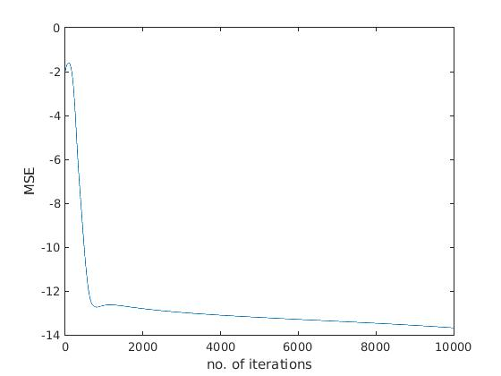

1) For two input xor gate

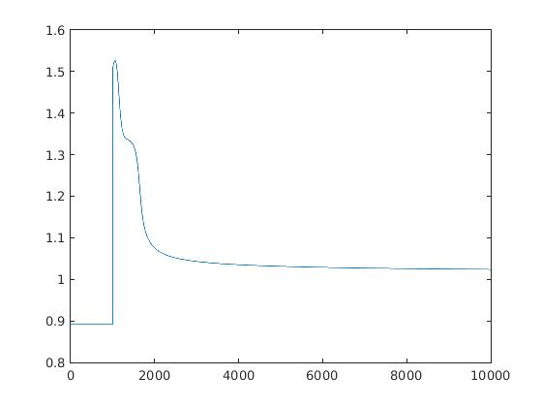

2) For three input xor gate

